PF – Lab Assignment 8

# Question 1:

**Write a C program to print the following pattern.**

**1**

**1 2**

**1 2 3**

**1 2 3 4**

**Code:**

**Output:**

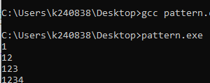

# Question 2:

**Write a program to take a 2D array input from the user and display its transpose.**

**Code:**

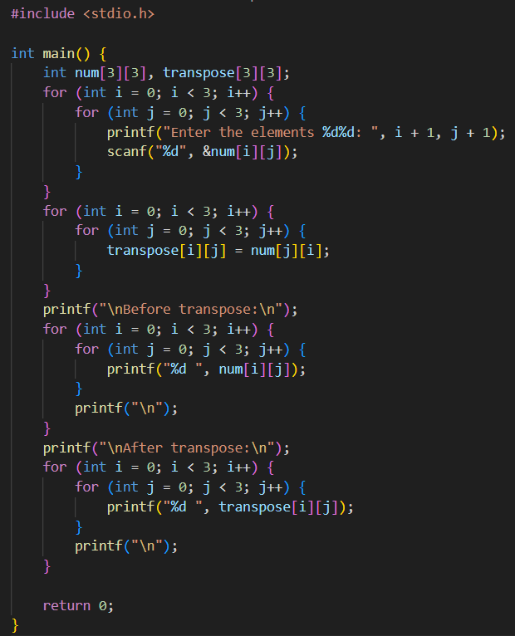

**Output:**

# **Question 3:**

**Create a 3D array representing 2 pages of a 3x3 matrix. Initialize it and find the sum of all the elements on each page.**

**Code:**

**Output:**

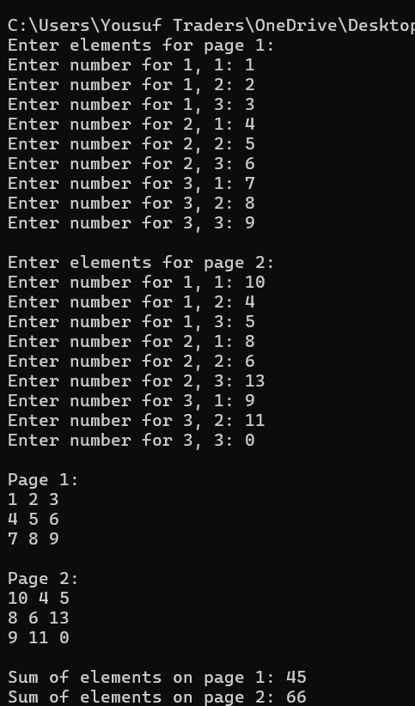

# Question 4:

**Write a C program that generates a sequence of prime numbers within a given range using nested loops.**

**Code:**

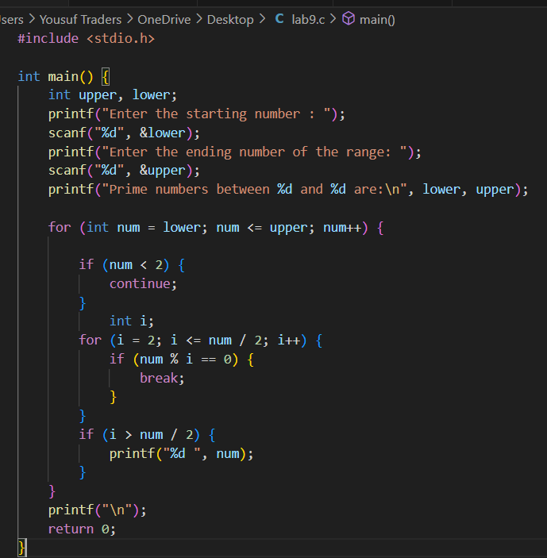

**Output:**

# Question 5:

**Generate a pattern of odd numbers in decreasing order starting from a user-specified number**

**using nested loops.**

**Code**

**Output**

## **Question 6:**

**Write a C program to find the saddle point(s) in a given 3x3 matrix. A saddle point is an element that is the smallest in its row and the largest in its column.**

**Code**

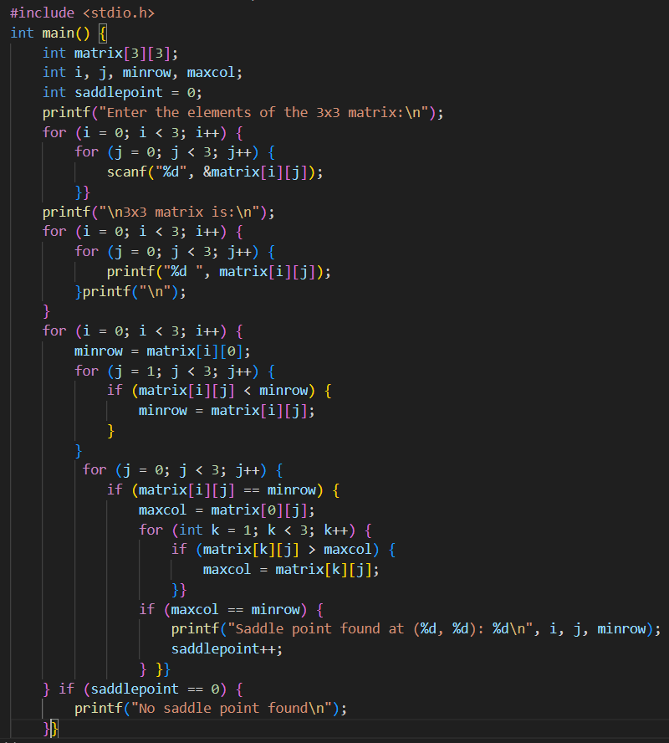

**Output**

## **Question 7:**

**Write a C program to multiply two matrices of size 3x3 and display the result matrix.**

**Code**

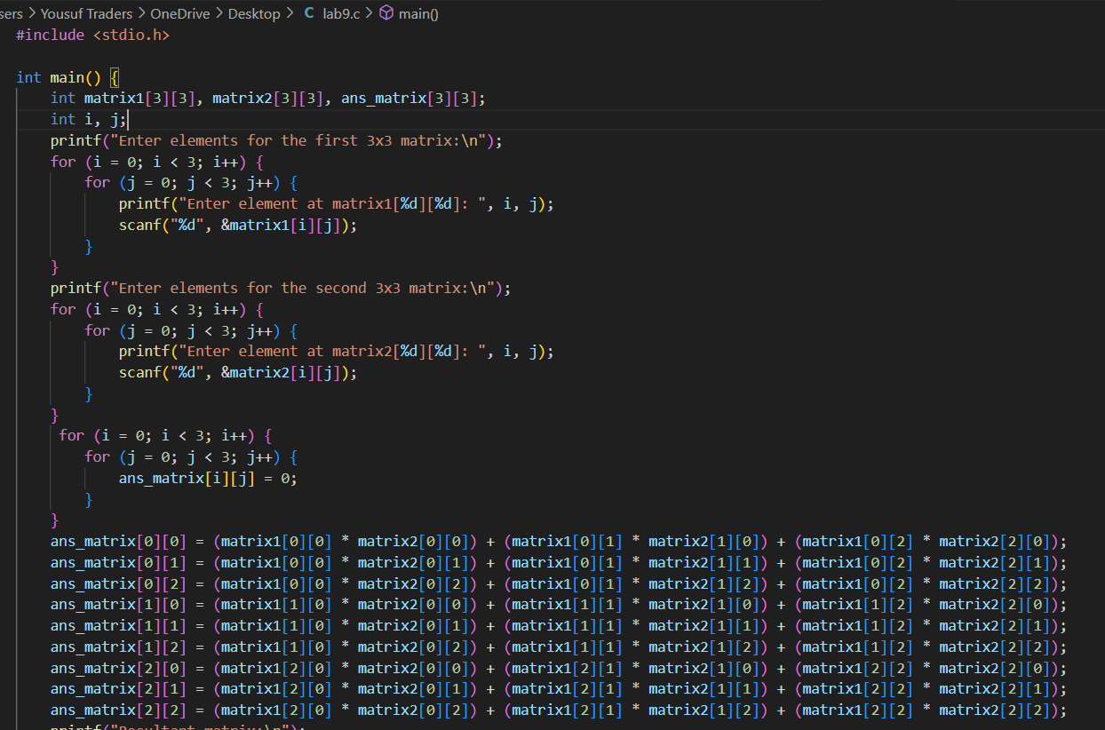

**Output**

## **Question 8:**

**Write a C program to generate a diamond shape pattern using nested loops. The program should take the number of rows for the upper half of the diamond as input from the user.**

**Code**

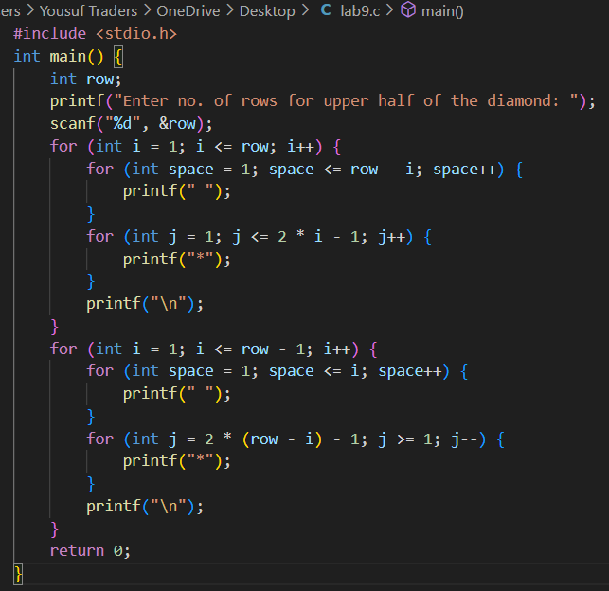

**Output**

